EXERCÍCIO FORM009.HTML

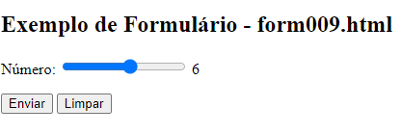

<**body**>

<h2>Exemplo de Formulário - form009.html</h2>

<**form** **action**="**cadastro**.**php**" **method**="**get**" **autocomplete**="**on**">

<p>

<**label** **for**="**i_num**">**Número:**</**label**>

<**input** **type**="**range**" **name**="**num**" **id**="**i_num**" **min**="**1**" **max**="**10**" **value**="**5**"

**oninput**="**ival.innerHTML** = **Number(i_num**.**value)**">

<**output** **id**="**ival**">**5**</**output**>

</p>

<p>

<**input** **type**="**submit**" **value**="**Enviar**">

<**input** **type**="**reset**" **value**="**Limpar**">

</p>

</**form**>

</**body**>